MEMORY REVISION

Complete the diagram below to show the multi store model of memory as outlined by Atkinson and Shiffrin, 1968.
Use the terms: attention, long-term memory, rehearsal, retrieval, rehearsal loop, recall, sensory memory and short-term memory. The multi store of

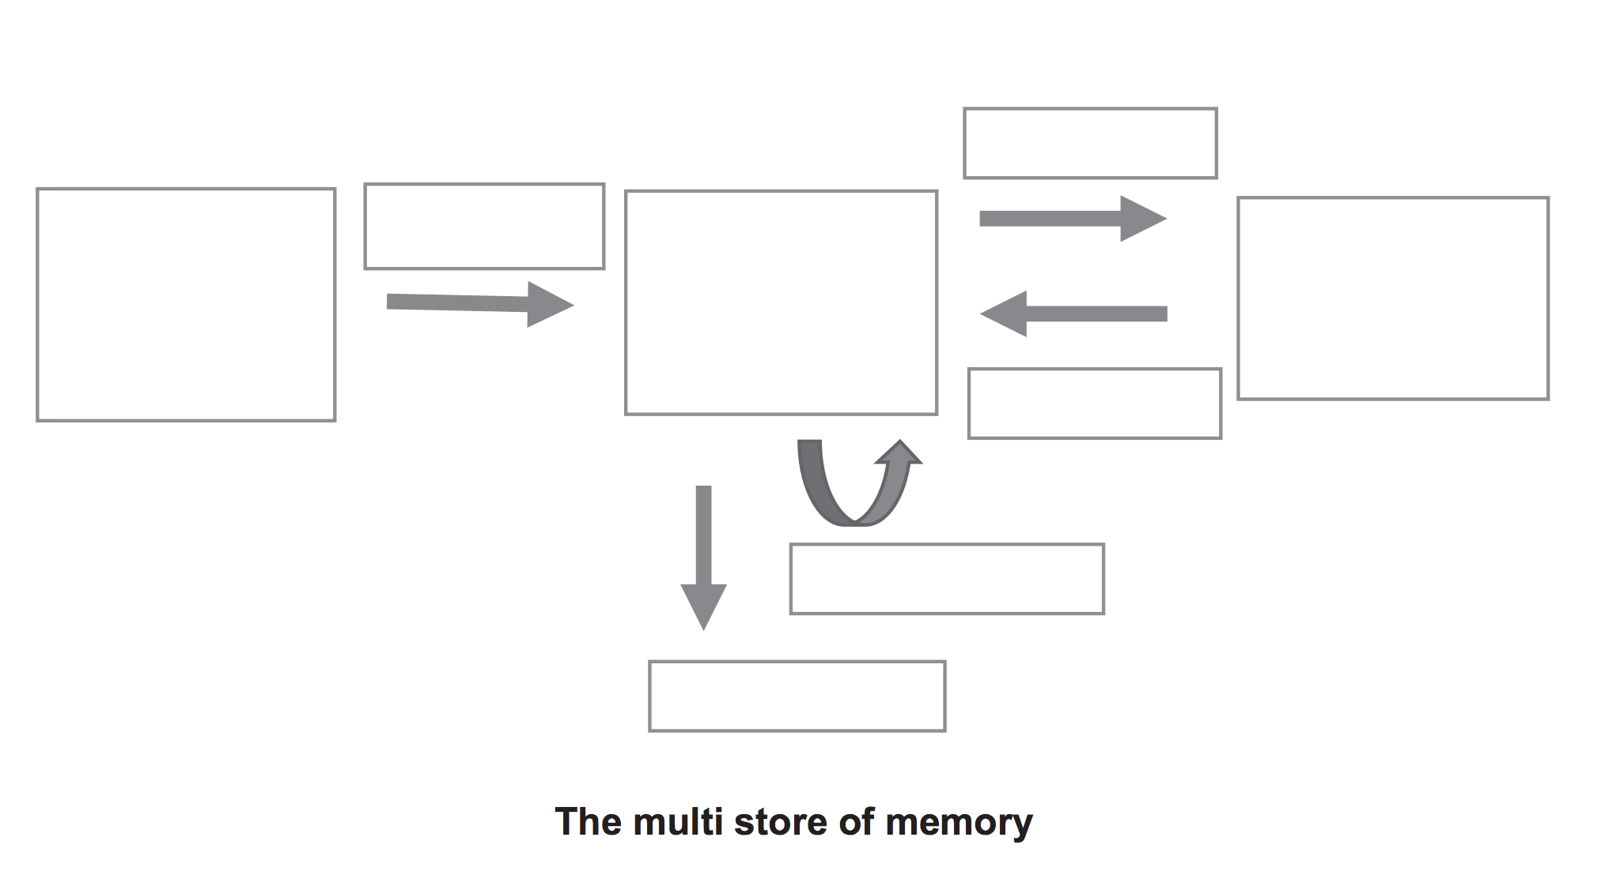

 | Sensory memory | Short-term memory | Long-term memory
Duration
Capacity

TYPES OF LONG TERM MEMORY | Procedural | Declarative
 |  | Episodic | Semantic
Describe
Example

Name the two types of rehearsal

__________ rehearsal – you say a phone number out loud a few times so you can write it down. No intention to put it into your long-term memory.
__________ rehearsal – make information more meaningful so you can store it and use it later.

Mnemonics are a way to put information into long-term memory by building more connections within your brain. Name the different types:

A_ _ _ _ _ _ _ S _ _ _ _ _ _ _
A _ _ _ _ _ _ _
S _ _ _ _
R _ _ _ _ _
V _ _ _ _ _ _ _ _ _ _ _ _
L _ _ _
N _ _ _ _ _ _ _ _

You can improve your memory by replicating the physical or internal state that you were in when you encoded the memory. Which of the following is not an example of this:
- Being underwater and remembering what you saw underwater last time
- Having caffeine in your system while you study and during a test
- Going to your old primary school and remembering what you used to do there
- Using memory tactics such as chunking to categorise information
- Being angry and remembering everything else that makes you angry

Perceptual set is the psychological factors that determine how you perceive the environment.
Which of the following is NOT one of these factors.

- Memory
- Context
- Sensation
- Emotions
- Motivations
- Culture

Perceptual expectancy is based on our _________ about the world.

ETHICS REVISION

Link up the Ethical guideline with the violation!

An experimenter is too invested in an experiment and influences the results by adjusting data or coercing participants. |  | Voluntary participation
Within a research paper, an experimenter uses names to identify participants. |  | Anonymity
Students are participants in a teaching experiment without knowing about it. |  | Role of the experimenter is to be unbiased and impartial.
Participants within an experiment are told what they are expected to do, but are not told about the risks and nature of the experiment. |  | Right to withdraw
An experimenter leaves personal information on their office desk (not locked away). |  | Full informed consent
Participants were deceived during an experiment and were not told about their misconceptions afterwards. |  | Confidentiality/privacy
Participants ask to leave an experiment but are refused by researchers. |  | Debrief

RESEARCH METHODS REVISION

To operationalise a hypothesis is to make a prediction that states:
- the relationship between variables
- how they will be measures
- who will be the participants

Make an operationalised hypothesis using the following:

- Use of 1 Tylenol tablet
- Self-report indicator of back pain (/10)
- Control group and experimental group
- Total of 30 participants

_______________________________________________________________________
_______________________________________________________________________
_______________________________________________________________________
_______________________________________________________________________

What is the independent variable?

_______________________________________________________________________

What is the dependent variable?

_______________________________________________________________________

Which participants are the control group?

_______________________________________________________________________

Is a self-report indication of pain (1-10) qualitative or quantitative?

_______________________________________________________________________

PAST TEST QUESTIONS

Eighteen year old David was about to purchase his first car. His mother was with him and proceeded to recall the story of when she purchased her first car. Outline the type of memory David’s mother was using to recall this information.
_______________________________________________________________________
_______________________________________________________________________
_______________________________________________________________________
_______________________________________________________________________

David’s 16-year-old sister needed to obtain her learners permit in order to learn how to drive. She had to sit a test that asked questions based on the road rules. Outline the type of memory David’s sister was relying on in the test.
_______________________________________________________________________
_______________________________________________________________________
_______________________________________________________________________

On the way home from purchasing his car, David got a flat tyre. He phoned his older sister, who had experience in changing a flat tyre. She found it difficult to explain exactly what David needed to do and decided it would be easier for her to change the tyre. Once she was at David’s car, she changed the tyre quickly and easily. Explain the type of memory David’s sister relied on to change the tyre successfully.
_______________________________________________________________________
_______________________________________________________________________
_______________________________________________________________________

Jay was trying to study for a test, but his friend Joan kept interrupting him. The next day, Jay struggled to recall the information he had studied, even though he had a good night’s sleep and his day had gone according to plan. Why could Jay not remember the information required?

_______________________________________________________________________
_______________________________________________________________________
_______________________________________________________________________

Memory is a complexed process of encoding, storing and retrieving information. Information from environmental stimuli is detected by sense organs. (a) Name three different forms of information that may be encoded. (3 marks)

One:_______________________________________________________________________ Two:______________________________________________________________________ Three:_____________________________________________________________________

A study conducted over a six-month period looked at the relationship between personality, motivation and human performance in teenage children. The participants were 60 year seven students, all aged 13 years (30 females and 30 males) from a local school called St. Gemma’s College. All students participated for the duration of the investigation. Students were required to complete a Likert scale survey every month administered by the researcher. Each survey asked questions about the participant’s personality, current motivation and academic results.

Without the students’ knowledge, the teachers within this school were accomplices in the research. Students were placed in one of the following groups:
● increased motivation – teachers used strategies to be more motivating
● control – teachers used ‘normal’ teaching strategies.

The research found that the students in the increased motivation group had statistically significant higher performance than those in the control group.

- Identify whether this investigation was experimental or non-experimental. Explain your choice with reference to the investigation. (3 marks)

_______________________________________________________________________
_______________________________________________________________________
_______________________________________________________________________
_______________________________________________________________________

(b) Write an operational hypothesis for this experiment.

_______________________________________________________________________
_______________________________________________________________________
_______________________________________________________________________

(c) Identify one uncontrolled variable and describe what impact this may have had on the research.

_______________________________________________________________________
_______________________________________________________________________
_______________________________________________________________________

(d) Discuss one ethical issue evident within this investigation and suggest one way this could have been remedied at the end of the experiment.
_______________________________________________________________________
_______________________________________________________________________

(d) Discuss one ethical issue evident within this investigation and suggest one way this could have been remedied at the end of the experiment.
_______________________________________________________________________
_______________________________________________________________________

